

Year 7 (Grade 6) Pre-test

English First Language

Instructions:

You have 60 minutes to complete this exam. Please write your name and school below and answer all of the following questions carefully.

Name:

_____________________________________________________________________

School:

_____________________________________________________________________

Examiner Only:

Score: ___/24

Section A: Grammar and Punctuation (5 marks)
1. Circle the sentence that is grammatically correct. (1 mark)
A. A collection of ancient fossils, along with several detailed excavation reports from the site, were stored in the archive beneath the museum.
B. A collection of ancient fossils, along with several detailed excavation reports from the site, are stored in the archive beneath the museum.
C. A collection of ancient fossils, along with several detailed excavation reports from the site, was stored in the archive beneath the museum.
D. A collection of ancient fossils, along with several detailed excavation reports from the site, have been stored in the archive beneath the museum
2. Choose the word that is formed correctly using a prefix or suffix. (1 mark)
A. unresponsable
B. irregularity
C. carefullness
D. misunderstandment
3. Choose the best conjunction to complete the sentence: (1 mark)
He practised every afternoon ______ he wanted to improve his performance.
A. but
B. because
C. although
D. moreover
4. Choose the sentence that is spelled correctly.
A. The headteacher recieved several complaints from parents.
B. The headteacher received several complaints from parents.
C. The headteacher receved several complaints from parents.
D. The headteacher reicieved several complaints from parents.
5. Rewrite the sentence below adding the correct punctuation and grammar: (1 mark)
after the match the team celebrated their victory

Section B: Language and Vocabulary (4 marks)
6. Choose the word closest in meaning to “hesitant.” (1 mark)
A. confident
B. unsure
C. excited
D. determined
7. Choose the most effective word to complete the sentence: (1 mark)
Salvador Dali’s art captured the minds of everyone who gazed upon it. His dazzling works were surreal, and full of colour. Even though he passed away a century ago his _____ works will be remembered by all.
A. weak
B. vivid
C. dull
D. simple
8. Which sentence uses the word “observe” correctly? (1 mark)
A. I observe very tired today.
B. She observed the birds carefully from the window.
C. The observe was interesting.
D. Scientist observe a new fungus found in Borneo today.
9. Write one synonym for the word “careful.” (1 mark)
_________________________________________________________________________

Section C: Reading Comprehension (6 marks)
Read the passage carefully and answer the questions that follow in full. Remember to support your claims with examples from the text. The passage is an extract from Chapter 1 of The Hobbit by J.R. Tolkien.
In a hole in the ground there lived a hobbit. Not a nasty, dirty, wet hole, filled with the ends of worms and an oozy smell, nor yet a dry, bare, sandy hole with nothing in it to sit down on or to eat: it was a hobbit-hole, and that means comfort.

It had a perfectly round door like a porthole, painted green, with a shiny yellow brass knob in the exact middle. The door opened on to a tube-shaped hall like a tunnel: a very comfortable tunnel without smoke, with panelled walls, and floors tiled and carpeted, provided with polished chairs, and lots and lots of pegs for hats and coats—the hobbit was fond of visitors.

The tunnel wound on and on, going fairly but not quite straight into the side of the hill—The Hill, as all the people for many miles round called it—and many little round doors opened out of it, first on one side and then on another. No going upstairs for the hobbit: bedrooms, bathrooms, cellars, pantries (lots of these), wardrobes (he had whole rooms devoted to clothes), kitchens, dining-rooms, all were on the same floor, and indeed on the same passage. The best rooms were all on the left-hand side (going in), for these were the only ones to have windows, deep-set round windows looking over his garden, and meadows beyond, sloping down to the river.

This hobbit was a very well-to-do hobbit, and his name was Baggins. The Bagginses had lived in the neighbourhood of The Hill for time out of mind, and people considered them very respectable, not only because most of them were rich, but also because they never had any adventures or did anything unexpected: you could tell what a Baggins would say on any question without the bother of asking him. This is a story of how a Baggins had an adventure, and found himself doing and saying things altogether unexpected. He may have lost the neighbours’ respect, but he gained—well, you will see whether he gained anything in the end.

The mother of our particular hobbit—what is a hobbit? I suppose hobbits need some description nowadays, since they have become rare and shy of the Big People, as they call us. They are (or were) a little people, about half our height, and smaller than the bearded Dwarves. Hobbits have no beards. There is little or no magic about them, except the ordinary everyday sort which helps them to disappear quietly and quickly when large stupid folk like you and me come blundering along, making a noise like elephants which they can hear a mile off. They are inclined to be fat in the stomach; they dress in bright colours (chiefly green and yellow); wear no shoes, because their feet grow natural leathery soles and thick warm brown hair like the stuff on their heads (which is curly); have long clever brown fingers, good-natured faces, and laugh deep fruity laughs (especially after dinner, which they have twice a day when they can get it). Now you know enough to go on with. As I was saying, the mother of this hobbit—of Bilbo Baggins, that is—was the famous Belladonna Took, one of the three remarkable daughters of the Old Took, head of the hobbits who lived across The Water, the small river that ran at the foot of The Hill. It was often said (in other families) that long ago one of the Took ancestors must have taken a fairy wife. That was, of course, absurd, but certainly there was still something not entirely hobbitlike about them, and once in a while members of the Took-clan would go and have adventures. They discreetly disappeared, and the family hushed it up; but the fact remained that the Tooks were not as respectable as the Bagginses, though they were undoubtedly richer.

Short Questions
10. How is Bilbo’s ‘hobbit hole’ described? Provide two examples from the text to support your answer. (2 marks)
_________________________________________________________________________
_________________________________________________________________________
_________________________________________________________________________
_________________________________________________________________________
_________________________________________________________________________
_________________________________________________________________________
11. What does a hobbit look like? Provide two physical features supported by the text. (2 marks)
_________________________________________________________________________
_________________________________________________________________________
_________________________________________________________________________
_________________________________________________________________________
_________________________________________________________________________
_________________________________________________________________________
12. Why do the other hobbits consider the Bagginses to be respectable? (2 marks)
_________________________________________________________________________
_________________________________________________________________________
_________________________________________________________________________
_________________________________________________________________________
_________________________________________________________________________
_________________________________________________________________________

Section D: Descriptive Writing (5 marks)
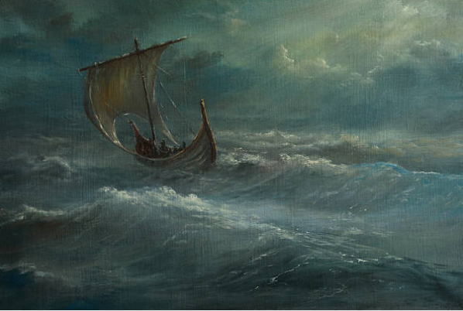
13. Write one short story based on the picture above. Use Standard English and correct punctuation throughout your writing. You will be marked on structure, content, and language used throughout the text.
_________________________________________________________________________
_________________________________________________________________________
_________________________________________________________________________
_________________________________________________________________________
_________________________________________________________________________
_________________________________________________________________________
_________________________________________________________________________
_________________________________________________________________________
_________________________________________________________________________
_________________________________________________________________________
_________________________________________________________________________
_________________________________________________________________________
_________________________________________________________________________
_________________________________________________________________________
_________________________________________________________________________
_________________________________________________________________________
_________________________________________________________________________
_________________________________________________________________________
_________________________________________________________________________
_________________________________________________________________________
_________________________________________________________________________
_________________________________________________________________________
_________________________________________________________________________
_________________________________________________________________________
_________________________________________________________________________
_________________________________________________________________________
_________________________________________________________________________
_________________________________________________________________________
_________________________________________________________________________
_________________________________________________________________________
_________________________________________________________________________
_________________________________________________________________________
_________________________________________________________________________
_________________________________________________________________________
_________________________________________________________________________
_________________________________________________________________________

